**Lenovo Notebook 10375FU IdeaPad G770 17.3inch Intel Core i3-2350M 4BG 500GB DVDRW USB2.0 Windows 7 Home Premium** 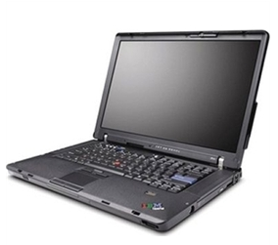

**Affordable product, high-price performance.**  
These laptops are an affordable, with all the essentials, with a few extra touches. The latest Intel processors, high-capacity storage, lots of RAM and Windows® 7, with RapidBoot technology, make them fast and efficient; cool design features, brilliant HD widescreens and powerful, switchable graphics make them fun to look at; and additional Lenovo apps and systems make them easy to connect, use and keep secure  
  
High-speed 802.11n Wi-Fi, with optional integrated Bluetooth®, for fast connectivity; Lenovo ReadyComm lets you easily manage your networking and internet connection; and Lenovo DirectShare allows you to synchronize your files with another notebook without having to connect to the internet. VeriFace® face recognition is a secure way to login to your PC. Lenovo Energy Management uses technology to stretch your battery life, protecting your battery's long-term durability. OneKey® Rescue System is there to simplify data backup and recovery.

Our laptops come with 1 year Vipre Antivirus, Office,